Update Re: ENT330 (IT Lifecycle Workshop) – ServiceNow Lab Requirements v4

Hi Sheeraz,

This document provides updated ServiceNow questions and clone lab instances requirements for the IT Lifecycle Workshop at re:Invent

The requirements below can be viewed in the following lab instance (please clone this instance if possible):

|  |  |  |
| --- | --- | --- |
| <https://rel-nov12shm789-007.lab.service-now.com/> | **UID:**  admin | **Password:**  mbs218 |

**ENT330 Lab Instance Quantities/Timeframes:**

Quantity: 100

Spin Up: No later than 11/20

Spin Down: Any time after 11/29

Clone Instance: <https://rel-nov12shm789-007.lab.service-now.com/>

**BAP206-R - Lifecycle Management of Amazon WorkSpaces Using the AWS Service Catalog Connector for ServiceNow**

Quantity: 2 (Instances Already Exist)

Instances Used for this Builder Session:

|  |  |  |
| --- | --- | --- |
| <https://rel-oct12shm-006.lab.service-now.com/> | admin | shm356 |
| https://rel-oct12shm-007.lab.service-now.com/ | admin | shm356 |

Spin Down: Any time after 11/29

**Pre-configured ENT330 IT Lifecycle Workshop - ServiceNow lab instance requirements:**

1. ServiceNow London release (latest patch)
2. AWS Service Catalog Connector for ServiceNow 1.6.7 update set
3. SNS Scoped app (Itai’s Blog); <https://github.com/byukich/x_snc_aws_sns>

*Note: This scoped app did not appear as an available module in ServiceNow’s standard user interface. The ServiceNow studio had an entry but code was not loaded.*  How can we ensure that doesn’t happen?

1. User Criteria Scoped API plugin – active

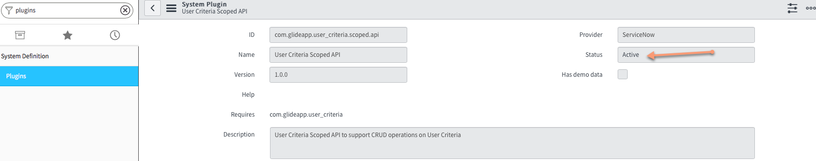

1. Add the AWS Service Catalog to the Service Catalog categories
2. Navigate to “Self Service” | Service Catalog” and select the “Add content” icon (top right):

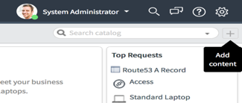

1. Select the “AWS Service Catalog Product” entry; add it to your catalog home page by choosing the first "Add Here" link on the second row of the selection panel at the bottom of the dialog.

|  |  |
| --- | --- |
|  |  |
|  |  |

1. 4 Pre-configured users that belong to a group with AWS Service Catalog scoped app roles

|  |  |  |  |
| --- | --- | --- | --- |
| **ServiceNow Users** | | | |
| UserID | Password | Group | **SC_Connector** Group Permissions |
| SCEndUser01 | MTSC@1 | SC_Connector | itil |
| SCEndUser02 | MTSC@1 | SC_Connector | x_126749_aws_sc_portfolio_manager |
| SCEndUser03 | MTSC@1 | SC_Connector | x_126749_aws_sc_account_admin |
| SCEndUser04 | MTSC@1 | SC_Connector | x_snc_aws_sns.admin |

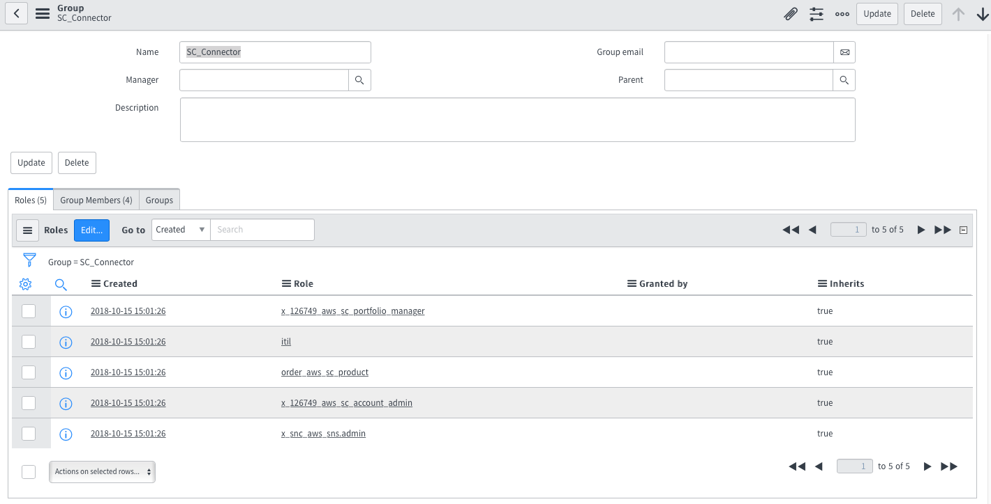

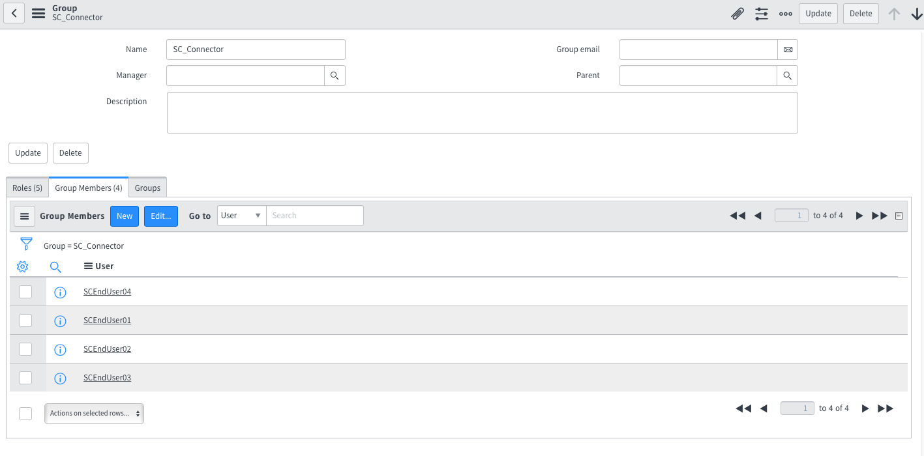

1. 1 new role (order_aws_sc_products) pre-configured

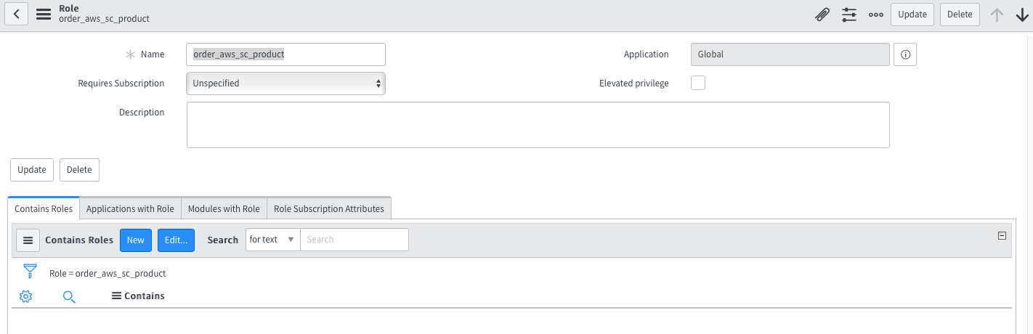

1. 1 new Change Type – AWS Provisioned Product Event
   1. **Table -** Change Request
   2. **Label -** AWS Provisioned Product Event
   3. **Value** – AWSProvisionedProductEvent
2. Accounts (in AWS Service Catalog scoped app) should be blank

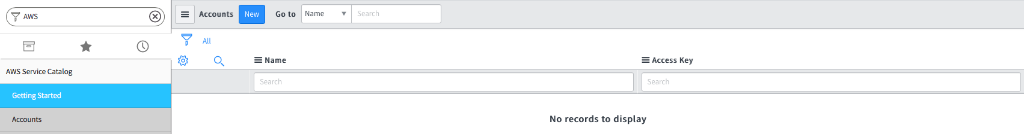

1. Identities (in AWS Service Catalog scoped app) should be blank

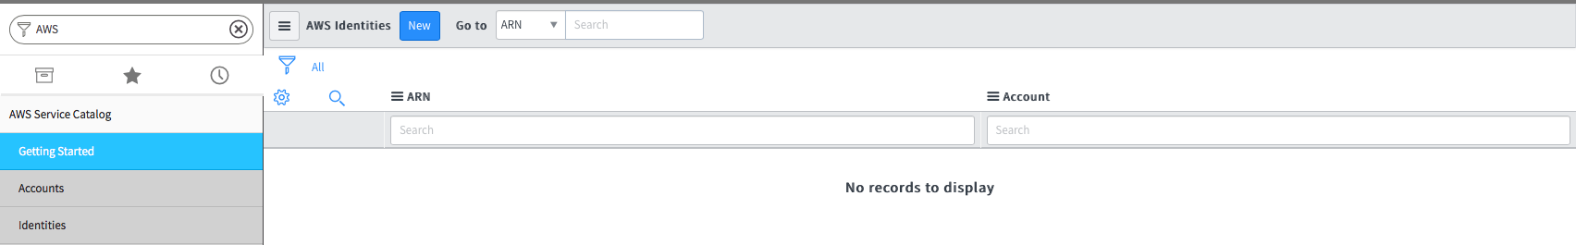

1. Portfolios(in AWS Service Catalog scoped app) should be blank

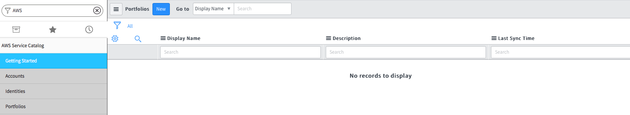

1. Products (in AWS Service Catalog scoped app) should be blank

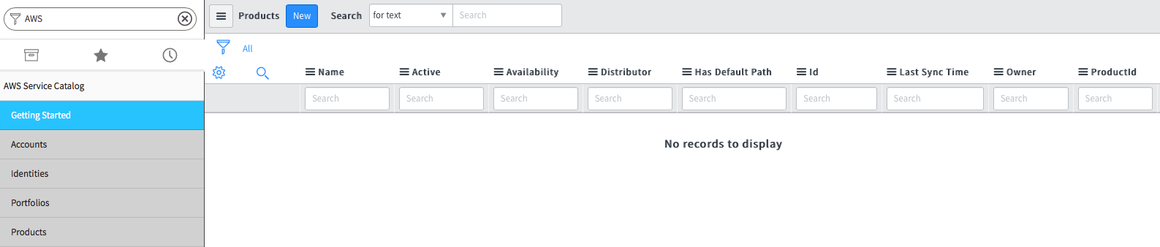

1. Role Grants (in AWS Service Catalog scoped app) should be blank

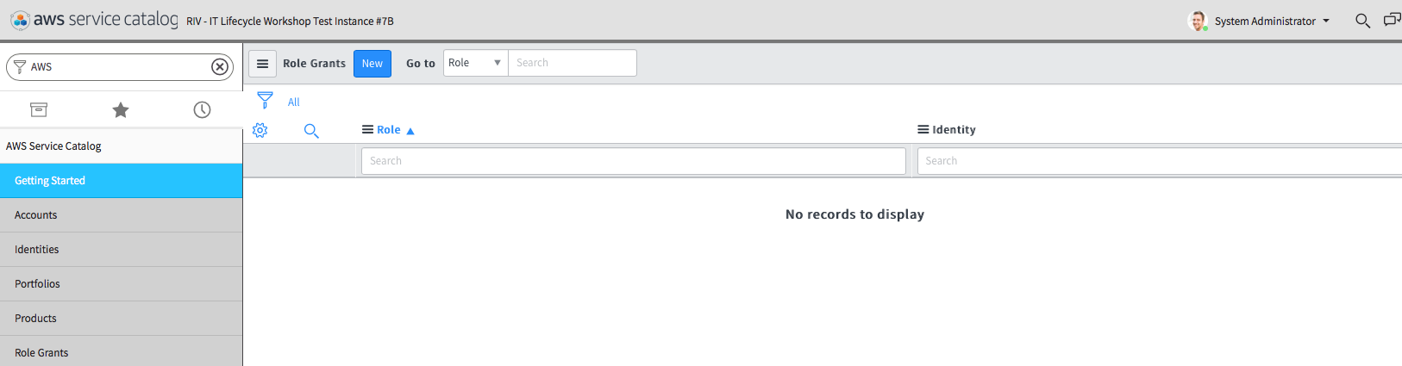

1. Provisioned Products (in AWS Service Catalog scoped app) should be blank

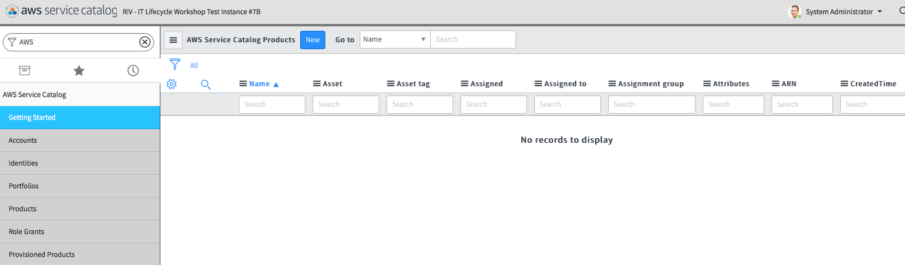

1. Subscriptions (in AWS SNS scoped app) should be blank

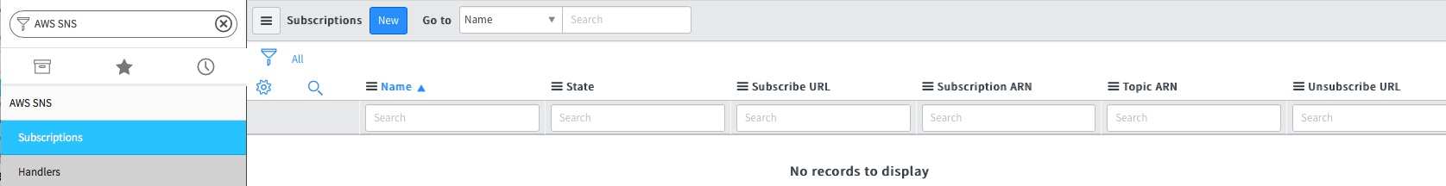

1. Handlers (in AWS SNS scoped app) should be blank

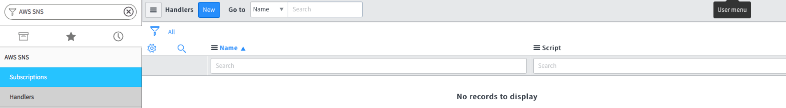

1. Log (in AWS SNS scoped app) should be blank

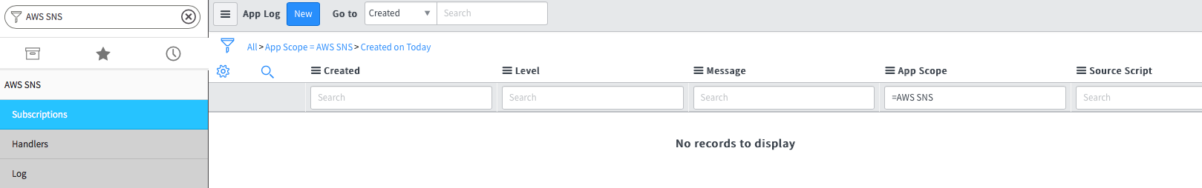

1. AWS Request Log (in AWS Service Catalog scoped app) should be blank

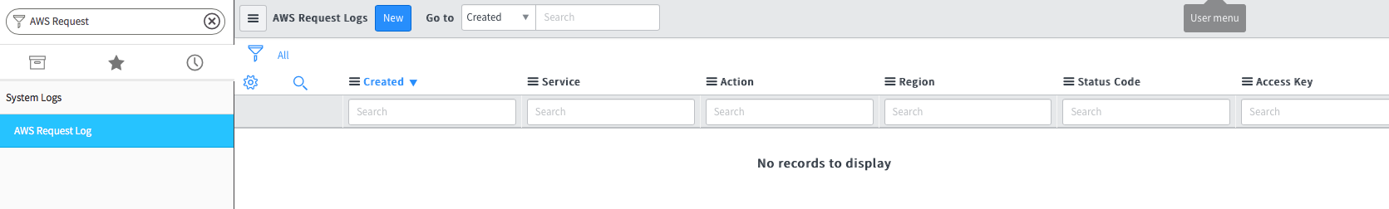

1. **My Assets** view preconfigured with configuration_item column



This means the configuration item (the product that was ordered) shows in the list of assets.

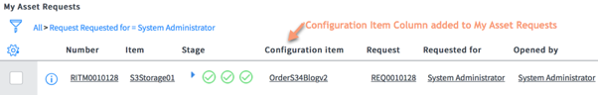

1. **My AWS Products** widget on the Designer - Service Portal index

